**ASSIGNMENT 1 (DIGITAL LOGIC AND CIRCUITS)**

**QUESTION a))**

**Minterm = 0,1,3,8,9,13,14,15,16,17,19,24,25,27,31  
DontCare = NONE  
Variable = A,B,C,D,E  
using Quine-McCluskey**

**INPUT EXPRESSION: Y = A’B’C’D’E’ + A’B’C’D’E + A’B’C’DE + A’BC’D’E’**

**+ A’BC’D’E + A’BCD’E + A’BCDE’ + A’BCDE**

**+ AB’C’D’E’ + AB’C’D’E + AB’C’DE + ABC’D’E’**

**+ ABC’D’E + ABC’DE + ABCDE**  
  
**Solution:**  
F(A,B,C,D,E) = ∑*m*(0,1,3,8,9,13,14,15,16,17,19,24,25,27,31)  
  
Variables = A,B,C,D,E  
1. min terms and their binary representations

Considering the number of ones .

|  |  |  |  |  |
| --- | --- | --- | --- | --- |
| Group G1 | |  |  |  | | --- | --- | --- | | 0 | 00000 | *** | |
| Group G2 | |  |  |  | | --- | --- | --- | | 1 | 00001 | *** | | 8 | 01000 | *** | | 16 | 10000 | *** | |
| Group G3 | |  |  |  | | --- | --- | --- | | 3 | 00011 | *** | | 9 | 01001 | *** | | 17 | 10001 | *** | | 24 | 11000 | *** | |
| Group G4 | |  |  |  | | --- | --- | --- | | 13 | 01101 | *** | | 14 | 01110 | *** | | 19 | 10011 | *** | | 25 | 11001 | *** | |
| Group G5 | |  |  |  | | --- | --- | --- | | 15 | 01111 | *** | | 27 | 11011 | *** | |
| Group G6 | |  |  |  | | --- | --- | --- | | 31 | 11111 | *** | |

2. merging of min term

|  |  |  |  |  |  |  |  |  |  |  |
| --- | --- | --- | --- | --- | --- | --- | --- | --- | --- | --- |
| Group H1 (G1,G2) | |  |  |  | | --- | --- | --- | | 0,1 | 0000- | *** | | 0,8 | 0-000 | *** | | 0,16 | -0000 | *** | |
| Group H2 (G2,G3) | |  |  |  | | --- | --- | --- | | 1,3 | 000-1 | *** | | 1,9 | 0-001 | *** | | 1,17 | -0001 | *** | | 8,9 | 0100- | *** | | 8,24 | -1000 | *** | | 16,17 | 1000- | *** | | 16,24 | 1-000 | *** | |
| Group H3 (G3,G4) | |  |  |  | | --- | --- | --- | | 3,19 | -0011 | *** | | 9,13 | 01-01 | ? | | 9,25 | -1001 | *** | | 17,19 | 100-1 | *** | | 17,25 | 1-001 | *** | | 24,25 | 1100- | *** | |
| Group H4 (G4,G5) | |  |  |  | | --- | --- | --- | | 13,15 | 011-1 | ? | | 14,15 | 0111- | ? | | 19,27 | 1-011 | *** | | 25,27 | 110-1 | *** | |
| Group H5 (G5,G6) | |  |  |  | | --- | --- | --- | | 15,31 | -1111 | ? | | 27,31 | 11-11 | ? | |

3. merging of min term pairs

|  |  |  |  |  |  |  |  |  |  |  |
| --- | --- | --- | --- | --- | --- | --- | --- | --- | --- | --- |
| Group J1 (H1,H2) | |  |  |  | | --- | --- | --- | | 0,1,8,9 | 0-00- | *** | | 0,1,16,17 | -000- | *** | | 0,8,16,24 | --000 | *** | |
| Group J2 (H2,H3) | |  |  |  | | --- | --- | --- | | 1,3,17,19 | -00-1 | ? | | 1,9,17,25 | --001 | *** | | 8,9,24,25 | -100- | *** | | 16,17,24,25 | 1-00- | *** | |
| Group J3 (H3,H4) | |  |  |  | | --- | --- | --- | | 17,19,25,27 | 1-0-1 | ? | |

4. merging of min term pairs

|  |  |  |  |  |
| --- | --- | --- | --- | --- |
| Group K1 (J1,J2) | |  |  |  | | --- | --- | --- | | 0,1,8,9,16,17,24,25 | --00- | ? | |

 1. Prime implicant chart

|  |  |  |  |  |  |  |  |  |  |  |  |  |  |  |  |  |
| --- | --- | --- | --- | --- | --- | --- | --- | --- | --- | --- | --- | --- | --- | --- | --- | --- |
| PIs\Minterms | 0 | 1 | 3 | 8 | 9 | 13 | 14 | 15 | 16 | 17 | 19 | 24 | 25 | 27 | 31 | A,B,C,D,E |
| 9,13 |  |  |  |  | X | X |  |  |  |  |  |  |  |  |  | 01-01 |
| 13,15 |  |  |  |  |  | X |  | X |  |  |  |  |  |  |  | 011-1 |
| 14,15 |  |  |  |  |  |  | X | X |  |  |  |  |  |  |  | 0111- |
| 15,31 |  |  |  |  |  |  |  | X |  |  |  |  |  |  | X | -1111 |
| 27,31 |  |  |  |  |  |  |  |  |  |  |  |  |  | X | X | 11-11 |
| 1,3,17,19 |  | X | X |  |  |  |  |  |  | X | X |  |  |  |  | -00-1 |
| 17,19,25,27 |  |  |  |  |  |  |  |  |  | X | X |  | X | X |  | 1-0-1 |
| 0,1,8,9,16,17,24,25 | X | X |  | X | X |  |  |  | X | X |  | X | X |  |  | --00- |

Extracted essential prime implicants : --00-,-00-1,0111-

2. Reduced Prime implicant chart

|  |  |  |  |  |
| --- | --- | --- | --- | --- |
| PIs\Minterms | 13 | 27 | 31 | A,B,C,D,E |
| 9,13 | X |  |  | 01-01 |
| 13,15 | X |  |  | 011-1 |
| 15,31 |  |  | X | -1111 |
| 27,31 |  | X | X | 11-11 |
| 17,19,25,27 |  | X |  | 1-0-1 |

Extracted essential prime implicants : 11-11

3. Reduced Prime implicant chart

|  |  |  |
| --- | --- | --- |
| PIs\Minterms | 13 | A,B,C,D,E |
| 9,13 | X | 01-01 |
| 13,15 | X | 011-1 |
| 15,31 |  | -1111 |
| 17,19,25,27 |  | 1-0-1 |

Extracted essential prime implicants : 01-01

All extracted essential prime implicants : --00-, -00-1, 0111-, 11-11, 01-01  
**Minimal QuineMcCluskey Expression = C'D' + B'C'E + A'BCD + ABDE + A'BD'E**

**TRUTH TABLE OF OUTPUT MINIMIZED EXPRESSION:**

|  |  |  |  |  |  |
| --- | --- | --- | --- | --- | --- |
| A | B | C | D | E | Y = C'D' + B'C'E + A'BCD + ABDE + A'BD'E |
| 0 | 0 | 0 | 0 | 0 | 1 |
| 0 | 0 | 0 | 0 | 1 | 1 |
| 0 | 0 | 0 | 1 | 0 | 0 |
| 0 | 0 | 0 | 1 | 1 | 1 |
| 0 | 0 | 1 | 0 | 0 | 0 |
| 0 | 0 | 1 | 0 | 1 | 0 |
| 0 | 0 | 1 | 1 | 0 | 0 |
| 0 | 0 | 1 | 1 | 1 | 0 |
| 0 | 1 | 0 | 0 | 0 | 1 |
| 0 | 1 | 0 | 0 | 1 | 1 |
| 0 | 1 | 0 | 1 | 0 | 0 |
| 0 | 1 | 0 | 1 | 1 | 0 |
| 0 | 1 | 1 | 0 | 0 | 0 |
| 0 | 1 | 1 | 0 | 1 | 1 |
| 0 | 1 | 1 | 1 | 0 | 1 |
| 0 | 1 | 1 | 1 | 1 | 1 |
| 1 | 0 | 0 | 0 | 0 | 1 |
| 1 | 0 | 0 | 0 | 1 | 1 |
| 1 | 0 | 0 | 1 | 0 | 0 |
| 1 | 0 | 0 | 1 | 1 | 1 |
| 1 | 0 | 1 | 0 | 0 | 0 |
| 1 | 0 | 1 | 0 | 1 | 0 |
| 1 | 0 | 1 | 1 | 0 | 0 |
| 1 | 0 | 1 | 1 | 1 | 0 |
| 1 | 1 | 0 | 0 | 0 | 1 |
| 1 | 1 | 0 | 0 | 1 | 1 |
| 1 | 1 | 0 | 1 | 0 | 0 |
| 1 | 1 | 0 | 1 | 1 | 1 |
| 1 | 1 | 1 | 0 | 0 | 0 |
| 1 | 1 | 1 | 0 | 1 | 0 |
| 1 | 1 | 1 | 1 | 0 | 0 |
| 1 | 1 | 1 | 1 | 1 | 1 |

**TRUTH TABLE OF INPUT EXPRESSION:**

|  |  |  |  |  |  |
| --- | --- | --- | --- | --- | --- |
| A | B | C | D | E | Y = A’B’C’D’E’ + A’B’C’D’E + A’B’C’DE + A’BC’D’E’ +  A’BC’D’E + A’BCD’E + A’BCDE’ + A’BCDE +  AB’C’D’E’ + AB’C’D’E + AB’C’DE + ABC’D’E’  + ABC’D’E + ABC’DE + ABCDE |
| 0 | 0 | 0 | 0 | 0 | 1 |
| 0 | 0 | 0 | 0 | 1 | 1 |
| 0 | 0 | 0 | 1 | 0 | 0 |
| 0 | 0 | 0 | 1 | 1 | 1 |
| 0 | 0 | 1 | 0 | 0 | 0 |
| 0 | 0 | 1 | 0 | 1 | 0 |
| 0 | 0 | 1 | 1 | 0 | 0 |
| 0 | 0 | 1 | 1 | 1 | 0 |
| 0 | 1 | 0 | 0 | 0 | 1 |
| 0 | 1 | 0 | 0 | 1 | 1 |
| 0 | 1 | 0 | 1 | 0 | 0 |
| 0 | 1 | 0 | 1 | 1 | 0 |
| 0 | 1 | 1 | 0 | 0 | 0 |
| 0 | 1 | 1 | 0 | 1 | 1 |
| 0 | 1 | 1 | 1 | 0 | 1 |
| 0 | 1 | 1 | 1 | 1 | 1 |
| 1 | 0 | 0 | 0 | 0 | 1 |
| 1 | 0 | 0 | 0 | 1 | 1 |
| 1 | 0 | 0 | 1 | 0 | 0 |
| 1 | 0 | 0 | 1 | 1 | 1 |
| 1 | 0 | 1 | 0 | 0 | 0 |
| 1 | 0 | 1 | 0 | 1 | 0 |
| 1 | 0 | 1 | 1 | 0 | 0 |
| 1 | 0 | 1 | 1 | 1 | 0 |
| 1 | 1 | 0 | 0 | 0 | 1 |
| 1 | 1 | 0 | 0 | 1 | 1 |
| 1 | 1 | 0 | 1 | 0 | 0 |
| 1 | 1 | 0 | 1 | 1 | 1 |
| 1 | 1 | 1 | 0 | 0 | 0 |
| 1 | 1 | 1 | 0 | 1 | 0 |
| 1 | 1 | 1 | 1 | 0 | 0 |
| 1 | 1 | 1 | 1 | 1 | 1 |

**MINIMIZED CIRCUIT WITH TWO INPUT NAND GATE:**

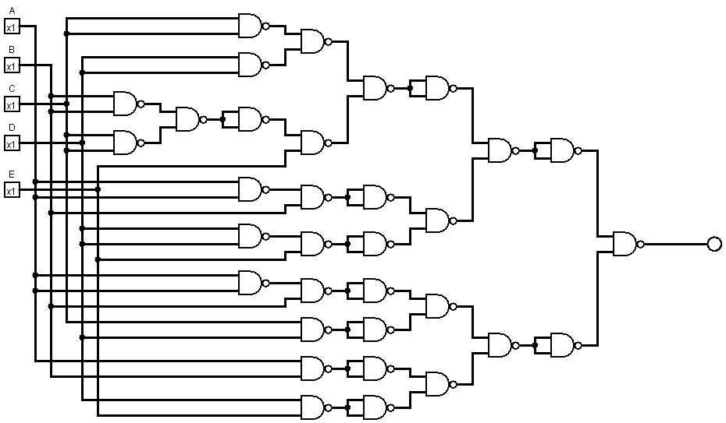

**OUTPUT**

**QUESTION b))**

**Minterm = 0,1,3,8,9,13,14,15,16,17,19,24,25,27,31  
DontCare = 5,7,15,18,26  
Variable = A,B,C,D,E  
using Quine-McCluskey**  
  
**Solution:**  
Minterm = ∑*m*(0,1,3,8,9,13,14,15,16,17,19,24,25,27,31)  
  
Variable = A,B,C,D,E  
Dontcare = ∑d(5,7,15,18,26)

F(A,B,C,D,E) = ∑*m*(0,1,3,8,9,13,14,15,16,17,19,24,25,27,31) + ∑d(5,7,15,18,26)  
  
  
As Max of Minterm is 31, So we have taken N = 5  
and Variable = A,B,C,D,E  
1. min terms and their binary representations

|  |  |  |  |  |  |
| --- | --- | --- | --- | --- | --- |
| Group G1 |  | |  |  |  | | --- | --- | --- | | 0 | 00000 | *** | |
| Group G2 |  | |  |  |  | | --- | --- | --- | | 1 | 00001 | *** | | 8 | 01000 | *** | | 16 | 10000 | *** | |
| Group G3 |  | |  |  |  | | --- | --- | --- | | 3 | 00011 | *** | | 9 | 01001 | *** | | 17 | 10001 | *** | | 24 | 11000 | *** | | 5 | 00101 | *** | | 18 | 10010 | *** | |
| Group G4 |  | |  |  |  | | --- | --- | --- | | 13 | 01101 | *** | | 14 | 01110 | *** | | 19 | 10011 | *** | | 25 | 11001 | *** | | 7 | 00111 | *** | | 26 | 11010 | *** | |
| Group G5 |  | |  |  |  | | --- | --- | --- | | 15 | 01111 | *** | | 27 | 11011 | *** | |
| Group G6 |  | |  |  |  | | --- | --- | --- | | 31 | 11111 | *** | |

2. merging of min term

|  |  |  |  |  |  |  |  |  |  |  |  |  |  |
| --- | --- | --- | --- | --- | --- | --- | --- | --- | --- | --- | --- | --- | --- |
| Group H1 (G1,G2) | |  |  |  |  | | --- | --- | --- | --- | |  | 0,1 | 0000- | *** | |  | 0,8 | 0-000 | *** | |  | 0,16 | -0000 | *** | |
| Group H2 (G2,G3) | |  |  |  | | --- | --- | --- | | 1,3 | 000-1 | *** | | 1,9 | 0-001 | *** | | 1,17 | -0001 | *** | | 1,5 | 00-01 | *** | | 8,9 | 0100- | *** | | 8,24 | -1000 | *** | | 16,17 | 1000- | *** | | 16,24 | 1-000 | *** | | 16,18 | 100-0 | *** | |
| Group H3 (G3,G4) | |  |  |  | | --- | --- | --- | | 3,19 | -0011 | *** | | 3,7 | 00-11 | *** | | 9,13 | 01-01 | *** | | 9,25 | -1001 | *** | | 17,19 | 100-1 | *** | | 17,25 | 1-001 | *** | | 24,25 | 1100- | *** | | 24,26 | 110-0 | *** | | 5,13 | 0-101 | *** | | 5,7 | 001-1 | *** | | 18,19 | 1001- | *** | | 18,26 | 1-010 | *** | |
| Group H4 (G4,G5) | |  |  |  | | --- | --- | --- | | 13,15 | 011-1 | *** | | 14,15 | 0111- | ? | | 19,27 | 1-011 | *** | | 25,27 | 110-1 | *** | | 7,15 | 0-111 | *** | | 26,27 | 1101- | *** | |
| Group H5 (G5,G6) | |  |  |  | | --- | --- | --- | | 15,31 | -1111 | ? | | 27,31 | 11-11 | ? | |

3. merging of min term pairs

|  |  |  |  |  |  |  |  |  |  |  |  |
| --- | --- | --- | --- | --- | --- | --- | --- | --- | --- | --- | --- |
| Group J1 (H1,H2) |  | |  |  |  | | --- | --- | --- | | 0,1,8,9 | 0-00- | *** | | 0,1,16,17 | -000- | *** | | 0,8,16,24 | --000 | *** | |
| Group J2 (H2,H3) |  | |  |  |  | | --- | --- | --- | | 1,5,9,13 | 0--01 | ? | | 1,3,17,19 | -00-1 | ? | | 1,9,17,25 | --001 | *** | | 1,3,5,7 | 00--1 | ? | | 8,9,24,25 | -100- | *** | | 16,17,24,25 | 1-00- | *** | | 16,18,24,26 | 1-0-0 | *** | | 16,17,18,19 | 100-- | *** | |
| Group J3 (H3,H4) |  | |  |  |  | | --- | --- | --- | | 17,19,25,27 | 1-0-1 | *** | | 24,25,26,27 | 110-- | *** | | 5,7,13,15 | 0-1-1 | ? | | 18,19,26,27 | 1-01- | *** | |

4. merging of min term pairs

|  |  |  |  |  |  |
| --- | --- | --- | --- | --- | --- |
| Group K1 (J1,J2) |  | |  |  |  | | --- | --- | --- | | 0,1,8,9,16,17,24,25 | --00- | ? | |
| Group K2 (J2,J3) |  | |  |  |  | | --- | --- | --- | | 16,17,18,19,24,25,26,27 | 1-0-- | ? | |

1. Prime implicant chart

|  |  |  |  |  |  |  |  |  |  |  |  |  |  |  |  |  |
| --- | --- | --- | --- | --- | --- | --- | --- | --- | --- | --- | --- | --- | --- | --- | --- | --- |
| PIs\Minterms | 0 | 1 | 3 | 8 | 9 | 13 | 14 | 15 | 16 | 17 | 19 | 24 | 25 | 27 | 31 | A,B,C,D,E |
| 14,15 |  |  |  |  |  |  | X | X |  |  |  |  |  |  |  | 0111- |
| 15,31 |  |  |  |  |  |  |  | X |  |  |  |  |  |  | X | -1111 |
| 27,31 |  |  |  |  |  |  |  |  |  |  |  |  |  | X | X | 11-11 |
| 1,5,9,13 |  | X |  |  | X | X |  |  |  |  |  |  |  |  |  | 0--01 |
| 1,3,17,19 |  | X | X |  |  |  |  |  |  | X | X |  |  |  |  | -00-1 |
| 1,3,5,7 |  | X | X |  |  |  |  |  |  |  |  |  |  |  |  | 00--1 |
| 5,7,13,15 |  |  |  |  |  | X |  | X |  |  |  |  |  |  |  | 0-1-1 |
| 0,1,8,9,16,17,24,25 | X | X |  | X | X |  |  |  | X | X |  | X | X |  |  | --00- |
| 16,17,18,19,24,25,26,27 |  |  |  |  |  |  |  |  | X | X | X | X | X | X |  | 1-0-- |

 Extracted essential prime implicants : --00-,0111-

2. Reduced Prime implicant chart

|  |  |  |  |  |  |  |
| --- | --- | --- | --- | --- | --- | --- |
| PIs\Minterms | 3 | 13 | 19 | 27 | 31 | A,B,C,D,E |
| 15,31 |  |  |  |  | X | -1111 |
| 27,31 |  |  |  | X | X | 11-11 |
| 1,5,9,13 |  | X |  |  |  | 0--01 |
| 1,3,17,19 | X |  | X |  |  | -00-1 |
| 1,3,5,7 | X |  |  |  |  | 00--1 |
| 5,7,13,15 |  | X |  |  |  | 0-1-1 |
| 16,17,18,19,24,25,26,27 |  |  | X | X |  | 1-0-- |

Extracted essential prime implicants : 11-11

3. Reduced Prime implicant chart

|  |  |  |  |  |
| --- | --- | --- | --- | --- |
| PIs\Minterms | 3 | 13 | 19 | A,B,C,D,E |
| 15,31 |  |  |  | -1111 |
| 1,5,9,13 |  | X |  | 0--01 |
| 1,3,17,19 | X |  | X | -00-1 |
| 1,3,5,7 | X |  |  | 00--1 |
| 5,7,13,15 |  | X |  | 0-1-1 |
| 16,17,18,19,24,25,26,27 |  |  | X | 1-0-- |

Extracted essential prime implicants : -00-1

4. Reduced Prime implicant chart

|  |  |  |
| --- | --- | --- |
| PIs\Minterms | 13 | A,B,C,D,E |
| 15,31 |  | -1111 |
| 1,5,9,13 | X | 0--01 |
| 1,3,5,7 |  | 00--1 |
| 5,7,13,15 | X | 0-1-1 |
| 16,17,18,19,24,25,26,27 |  | 1-0-- |

Extracted essential prime implicants : 0--01

All extracted essential prime implicants : --00-,0111-,11-11,-00-1,0—01

**Minimal QuineMcCluskey Expression = C'D' + A'BCD + ABDE + B'C'E + A'D'E**

**OUTPUT EXPRESSION TRUTH TABLE:**

|  |  |  |  |  |  |
| --- | --- | --- | --- | --- | --- |
| A | B | C | D | E | Y = C'D' + A'BCD + ABDE + B'C'E + A'D'E |
| 0 | 0 | 0 | 0 | 0 | 1 |
| 0 | 0 | 0 | 0 | 1 | 1 |
| 0 | 0 | 0 | 1 | 0 | 0 |
| 0 | 0 | 0 | 1 | 1 | 1 |
| 0 | 0 | 1 | 0 | 0 | 0 |
| 0 | 0 | 1 | 0 | 1 | 1 |
| 0 | 0 | 1 | 1 | 0 | 0 |
| 0 | 0 | 1 | 1 | 1 | 0 |
| 0 | 1 | 0 | 0 | 0 | 1 |
| 0 | 1 | 0 | 0 | 1 | 1 |
| 0 | 1 | 0 | 1 | 0 | 0 |
| 0 | 1 | 0 | 1 | 1 | 0 |
| 0 | 1 | 1 | 0 | 0 | 0 |
| 0 | 1 | 1 | 0 | 1 | 1 |
| 0 | 1 | 1 | 1 | 0 | 1 |
| 0 | 1 | 1 | 1 | 1 | 1 |
| 1 | 0 | 0 | 0 | 0 | 1 |
| 1 | 0 | 0 | 0 | 1 | 1 |
| 1 | 0 | 0 | 1 | 0 | 0 |
| 1 | 0 | 0 | 1 | 1 | 1 |
| 1 | 0 | 1 | 0 | 0 | 0 |
| 1 | 0 | 1 | 0 | 1 | 0 |
| 1 | 0 | 1 | 1 | 0 | 0 |
| 1 | 0 | 1 | 1 | 1 | 0 |
| 1 | 1 | 0 | 0 | 0 | 1 |
| 1 | 1 | 0 | 0 | 1 | 1 |
| 1 | 1 | 0 | 1 | 0 | 0 |
| 1 | 1 | 0 | 1 | 1 | 1 |
| 1 | 1 | 1 | 0 | 0 | 0 |
| 1 | 1 | 1 | 0 | 1 | 0 |
| 1 | 1 | 1 | 1 | 0 | 0 |
| 1 | 1 | 1 | 1 | 1 | 1 |

**INPUT EXPRESSION TRUTH TABLE:**

|  |  |  |  |  |  |
| --- | --- | --- | --- | --- | --- |
| A | B | C | D | E | Y = A’B’C’D’E’ + A’B’C’D’E + A’B’C’DE + A’BC’D’E’ +  A’BC’D’E + A’BCD’E + A’BCDE’ + A’BCDE +  AB’C’D’E’ + AB’C’D’E + AB’C’DE + ABC’D’E’  + ABC’D’E + ABC’DE + ABCDE  (Don’t Cares: 5,7,15,18,26) |
| 0 | 0 | 0 | 0 | 0 | 1 |
| 0 | 0 | 0 | 0 | 1 | 1 |
| 0 | 0 | 0 | 1 | 0 | 0 |
| 0 | 0 | 0 | 1 | 1 | 1 |
| 0 | 0 | 1 | 0 | 0 | 0 |
| 0 | 0 | 1 | 0 | 1 | 1 |
| 0 | 0 | 1 | 1 | 0 | 0 |
| 0 | 0 | 1 | 1 | 1 | 0 |
| 0 | 1 | 0 | 0 | 0 | 1 |
| 0 | 1 | 0 | 0 | 1 | 1 |
| 0 | 1 | 0 | 1 | 0 | 0 |
| 0 | 1 | 0 | 1 | 1 | 0 |
| 0 | 1 | 1 | 0 | 0 | 0 |
| 0 | 1 | 1 | 0 | 1 | 1 |
| 0 | 1 | 1 | 1 | 0 | 1 |
| 0 | 1 | 1 | 1 | 1 | 1 |
| 1 | 0 | 0 | 0 | 0 | 1 |
| 1 | 0 | 0 | 0 | 1 | 1 |
| 1 | 0 | 0 | 1 | 0 | 0 |
| 1 | 0 | 0 | 1 | 1 | 1 |
| 1 | 0 | 1 | 0 | 0 | 0 |
| 1 | 0 | 1 | 0 | 1 | 0 |
| 1 | 0 | 1 | 1 | 0 | 0 |
| 1 | 0 | 1 | 1 | 1 | 0 |
| 1 | 1 | 0 | 0 | 0 | 1 |
| 1 | 1 | 0 | 0 | 1 | 1 |
| 1 | 1 | 0 | 1 | 0 | 0 |
| 1 | 1 | 0 | 1 | 1 | 1 |
| 1 | 1 | 1 | 0 | 0 | 0 |
| 1 | 1 | 1 | 0 | 1 | 0 |
| 1 | 1 | 1 | 1 | 0 | 0 |
| 1 | 1 | 1 | 1 | 1 | 1 |

**MINIMIZED CIRCUIT WITH TWO INPUT NAND GATE:**

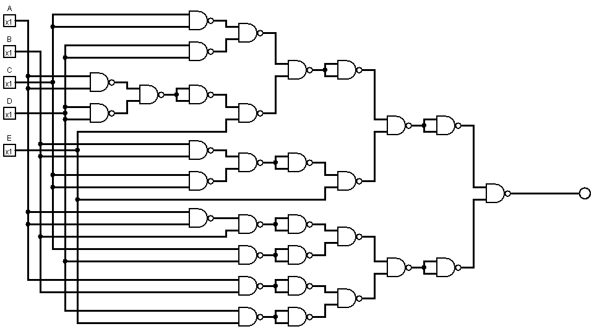

**OUTPUT**